3 * 16CH H.264 SD encoder

GN-1846B

GN-1846B is a new product in the Gospel SD encoding series. This product can simultaneously perform SD H.264 compression encoding on up to 48 analog audio and video input signals, multiplex the encoded code stream, and then output through the IP interface. This product can be applied to the source code of the digital TV network front end, and supports WEB-based management.

Front panel：
Rear panel
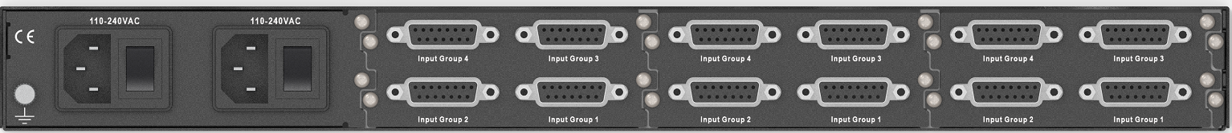

Main Feature：
- Support 48-channel H.264 encoding
- Encoding resolution: 720 * 576P25, 720 * 480P30
- Support ultra-low bit rate encoding
- Independently set audio encoding bit rate: 64, 96, 128, 192Kbps (MPEG-1 L2)
- Video output bit rate range: 0.5 ～ 3.2Mbps
- System output bit rate range: 2 ～ 60Mbps
- MPEG TS-over-IP output, support SPTS mode
- UDP / RTP payload is 7 TS streams with a length of 188 bytes
- Automatically save user's configuration
- Power-down memory function

Technical specifications：

Input
Type | DB15
Number | Single board 4 groups (CVBS, L & R Audio)
IP Output
Number | 1
Type | RJ-45 10/100 Base-T
format | MPEG TS-over-IP
Encoding
Video format | H.264/AVC
Audio format | MPEG-1 L2
Audio sampling rate | 32kHz、
Video encoding bit rate | 0.5~3.2Mbps
Audio encoding bit rate | 96kbps～192 kbps
PSI/SI insert | PAT、PMT、SDT insert
management
Interface Type | RJ-45 10/100 Base-T
Interface | RJ-45
Power consumption
voltage range | 85 - 260V AC
frequency range | 50/60Hz

